**ASSIGNMENT – 1**

|  |  |
| --- | --- |
| Assignment Date | 14 September 2022 |
| Student Name | Ms. KOTA SRILAKSHMI |
| Student Roll Number | 111519106074 |
| Maximum Marks | 2 Marks |

Create a circuit with piezo alarm, PIR sensor with below functionalities :

1. Alarm should sound in one manner if temp is above 60 C

2. Alarm should sound with another frequency if motion is detected in PIR sensor

Circuit with Piezo alarm, PIR sensor and Temperature Sensor

**CIRCUIT DIAGRAM:**

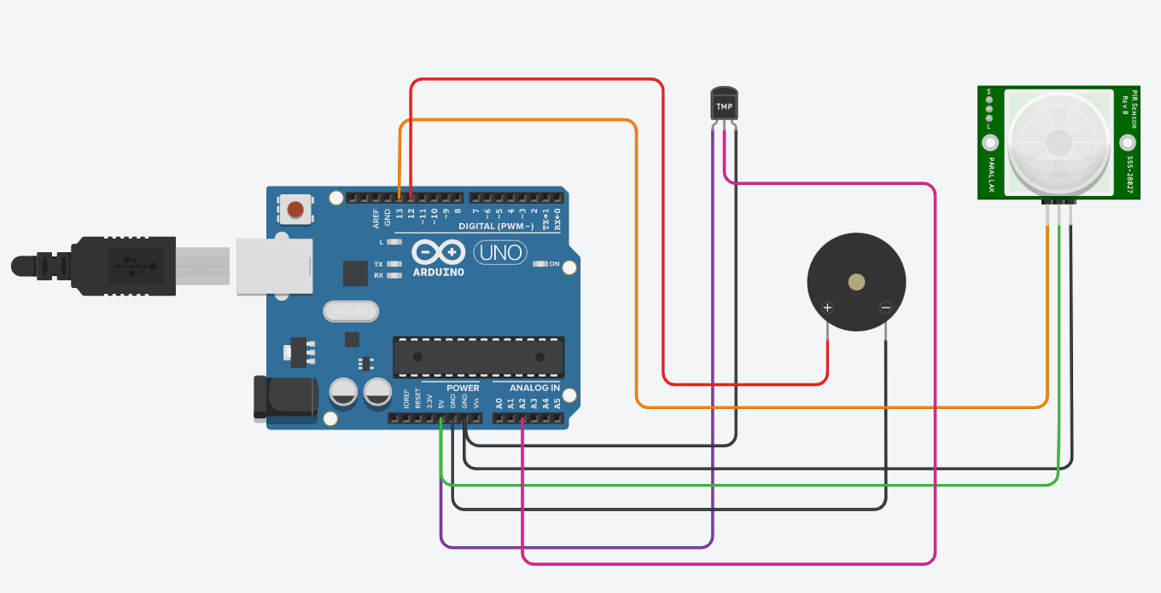

**CODE:**

void setup()

{

Serial.begin(9600);

pinMode(13,INPUT);

pinMode(12,OUTPUT);

}

void loop()

{

double data=analogRead(A2);

double n=data/1024;

double volt=n*5;

double off=volt-0.5;

double temperature=off*100;

int motion=digitalRead(13);

for(int freq=4;freq<=5;freq++)

{

if(temperature>=60)

{

Serial.println("Temperature is above 60");

tone(12,freq);

delay(100);

}

else

{

Serial.println("Temperature is below 60");

noTone(12);

}

}

for(int freq=2;freq<=3;freq++)

{

if(motion==1)

{

Serial.println("Motion Detected");

tone(12,freq);

delay(200);

}

else

{

Serial.println(" No Motion");

noTone(12);

}

}

}

**OUTPUT:**

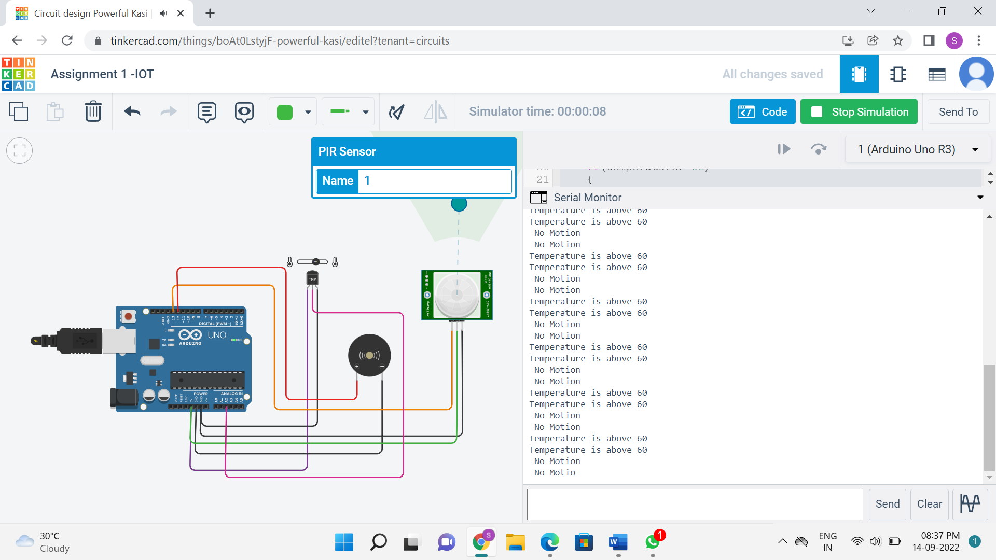

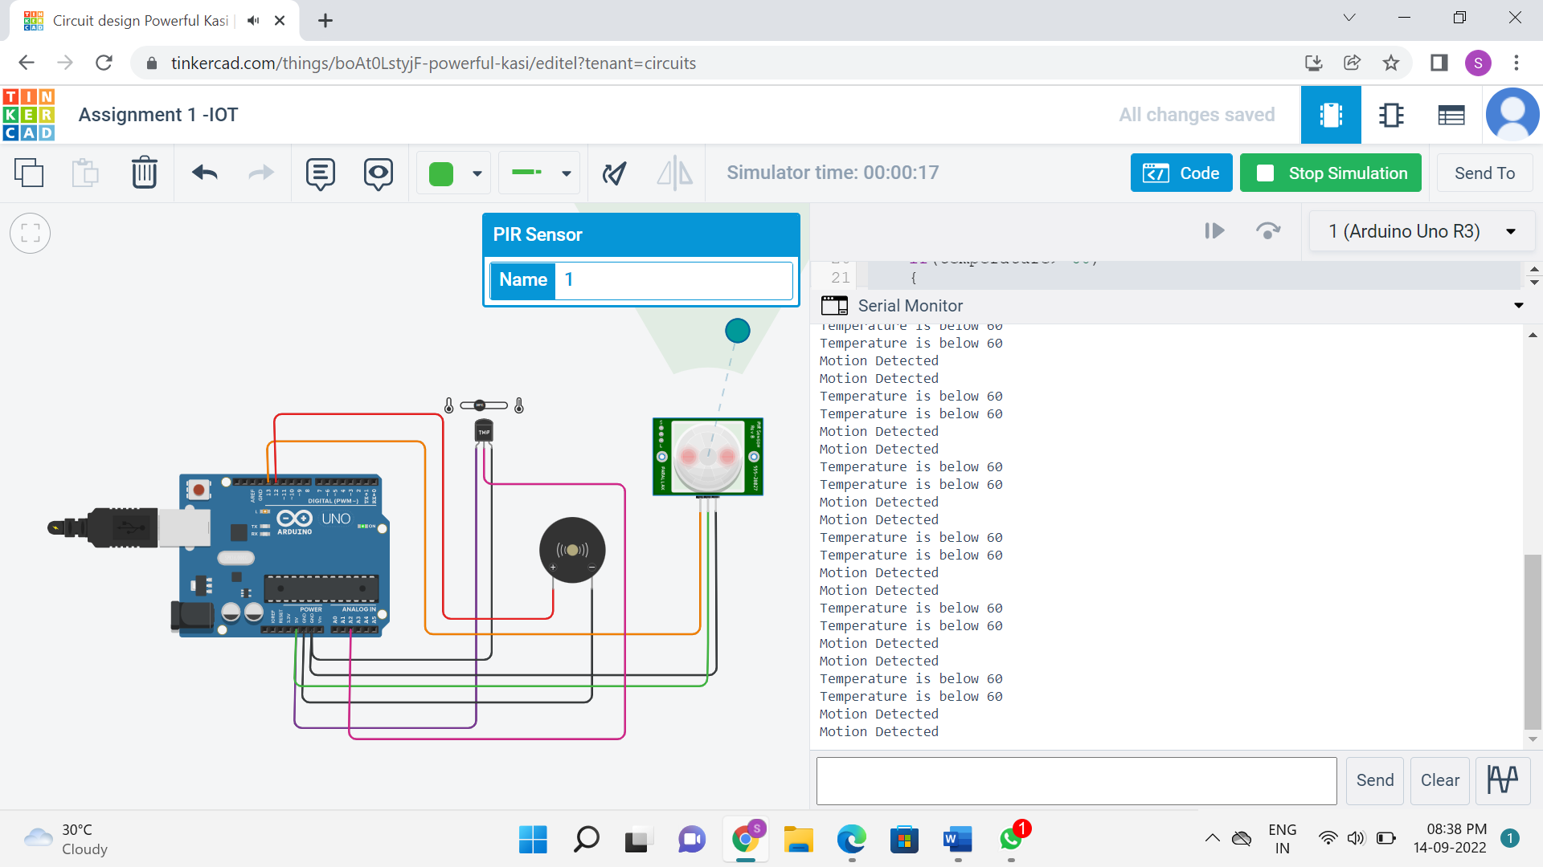

**VIDEO LINK:**

https://drive.google.com/file/d/145_JwTFMA4OaQ1O6A10rr_5Y3yMdj30z/view?usp=sharing